

SMART CAMPUS NAVIGATION SYSTEM USING INTERACTIVE MAPS
A CAPSTONE PROJECT REPORT
A Capstone Project Report submitted in partial fulfilment of the requirements
for the Course of
CSA1006 – SOFTWARE ENGINEERING
to the award of the degree of
BACHELOR OF TECHNOLOGY
IN
SOFTWARE ENGINEERING
Submitted by
K. Srinivasa Reddy (192525452)

Under the Supervision of
Dr. R. Surendran
SIMATS ENGINEERING
Saveetha Institute of Medical and Technical Sciences
Chennai-602105
SEPTEMBER 2026

SIMATS ENGINEERING
Saveetha Institute of Medical and Technical Sciences
Chennai-602105

BONAFIDE CERTIFICATE
This is to certify that the Capstone Project entitled “Smart Campus Navigation System Using Interactive Maps” has been carried out by K. Srinivasa Reddy (192525452), under the supervision of Dr. R. Surendran and is submitted in partial fulfilment of the requirements for the current semester of the B.Tech Software Engineering course at Saveetha Institute of Medical and Technical Sciences, Chennai.
PROGRAM DIRECTOR COURSE COORDINATOR
Dr. Sriramya Chandrasekaran Dr. K. Anita Davamani
Program Director Professor, Nxt-Gen Computing Dr. K. Anita Davamani Course Coordinator

SIMATS ENGINEERING
Saveetha Institute of Medical and Technical Sciences
Chennai-602105

DECLARATION
I, K. Srinivasa Reddy, of the Software Engineering course, SIMATS Engineering, Saveetha Institute of Medical and Technical Sciences, Chennai, hereby declare that the Capstone Project Work entitled “Smart Campus Navigation System Using Interactive Maps” is the result of our own bonafide efforts. To the best of our knowledge, the work presented herein is original, accurate, and has been carried out in accordance with the principles of engineering ethics and academic integrity.
All sources, references, data, software resources, computational resources, and other materials used in the project have been appropriately acknowledged. We further declare that the data, results, analysis, and findings presented in this report have not been fabricated, falsified, or deliberately manipulated. Any external software libraries, web mapping resources, open-source resources, or AI-assisted tools used during the project have been appropriately disclosed. We confirm that applicable ethical, academic, institutional, and professional requirements have been followed throughout the planning, implementation, testing, and documentation of the project.
Place: Chennai
Date: September 2026
Signatures of the Students with Names
K. Srinivasa Reddy

SIMATS ENGINEERING
Saveetha Institute of Medical and Technical Sciences
Chennai-602105

INDIVIDUAL CONTRIBUTION STATEMENT

Student Name / Reg. No. | Specific Responsibilities | Design & Development | Testing & Analysis | Report Contribution | Approx. Contribution (%)
K. Srinivasa Reddy  192525452 | Interactive map interface, building search and UI integration | Map interface and search workflow | Map interaction and usability testing | Ch. 1 and Ch. 3 sections | 25%
Srivatsan L  192521480 | Route-finder logic and navigation workflow | Source/destination and route display | Route accuracy and path verification | Ch. 4 sections | 25%
Harendra G  192521215 | Admin functions, database structure and building information | Data model and administration workflow | CRUD/data consistency checks | Ch. 3 and Appendix sections | 25%
Rushil Vignesh S  192511114 | System integration, 3D/satellite presentation and documentation | Module integration and presentation layer | System-level validation and screenshots | Ch. 2 and Ch. 5 sections | 25%
Total |  |  |  |  | 100%

ABSTRACT
Large educational campuses contain multiple academic buildings, departments, classrooms, laboratories and support facilities, making physical wayfinding difficult for freshers, visitors and new staff. Traditional signboards and printed maps provide limited contextual information and require users to interpret the campus layout manually. The project addresses this engineering problem by developing a web-based Smart Campus Navigation System Using Interactive Maps that combines searchable campus information, interactive map visualization and route-finding functions in a single interface.
The proposed system is organized into three principal modules: User & Interactive Map, Navigation & Route Finder, and Admin & Database. The first module provides login, interactive map display, building search, building selection, zoom controls and location details. The second module accepts a source and destination, determines a shortest route and presents the navigation path, distance and directions. The third module allows authorized administration of buildings, departments, map information and user accounts. The presentation describes a 3D WebGL-based campus representation with satellite-view support, floating 3D text badges, room highlighting and one-click map movement.
The development follows Software Engineering principles by translating stakeholder needs into functional and non-functional requirements, decomposing the system into modules, defining interfaces between components, implementing the web application, and validating the major workflows through functional and usability-oriented tests. The prototype shown in the project presentation demonstrates interactive campus visualization, building information, room highlighting and navigation-oriented map interaction. The reported outcome is a functional prototype intended to reduce search time and confusion while improving the overall campus navigation experience on desktop and mobile devices.
The project demonstrates how interactive mapping and structured campus data can be integrated into a maintainable software system. Future extensions can include accessibility-aware routing, indoor positioning, real-time occupancy information, multilingual support, offline maps and mobile-native deployment.
Keywords: Smart Campus, Interactive Maps, Campus Navigation, Route Finder, 3D WebGL, Software Engineering

TABLE OF CONTENTS
Sl. No. | Title | Page No.
i | Title Page | i
ii | Certificate from the Supervisor | ii
iii | Declaration by the Candidate | iii
iv | Individual Contribution Statement | iv
v | Abstract | v
vi | List of Figures | vi
vii | List of Tables | vii
viii | List of Abbreviations / Symbols | viii
1 | CHAPTER 1: Introduction and Engineering Problem | 9
 | 1.1 Background | 9
 | 1.2 Need for the Project | 9
 | 1.3 Problem Statement | 10
 | 1.4 Project Aim | 10
 | 1.5 Project Objectives | 10
 | 1.6 Scope | 11
 | 1.7 Expected Engineering Outcome | 11
2 | CHAPTER 2: Literature Review and Existing Solutions | 12
 | 2.1 Review Method | 12
 | 2.2 Review of Existing Work | 12
 | 2.3 Comparative Analysis | 12
 | 2.4 Research / Engineering Gap | 12
 | 2.5 Proposed Contribution | 13
3 | CHAPTER 3: Engineering Design & Trade-offs, Sustainability, Ethics, Safety, Risk & Security | 14
 | 3.1 Requirements | 14
 | 3.2 Constraints & Applicable Standards | 14
 | 3.3 Design Specifications | 15
 | 3.4 Alternative Solutions & Evaluation | 15
 | 3.5 Selected Design & Detailed Design | 15
 | 3.6 Trade-off Analysis | 18
 | 3.7 Sustainability, Ethics, Safety, Risk & Security | 18
4 | CHAPTER 4: Implementation, Testing & Results, Project Management | 19
 | 4.1 Development Approach & Resources | 19
 | 4.2 Software Implementation & Modern Tools Used | 19
 | 4.3 Test Plan & Verification | 21
 | 4.4 Results | 22
 | 4.5 Data Analysis & Engineering Judgment | 22
 | 4.6 Comparison with Existing Solutions & Achievement of Objectives | 22
 | 4.7 Strengths & Limitations | 22
 | 4.8 Project Planning, Roles & Budget | 23
5 | CHAPTER 5: Conclusion, Future Work and Reflection | 24
 | 5.1 Conclusion | 24
 | 5.2 Future Work | 24
 | 5.3 Professional Learning & Individual Reflection | 24
 | References | 26
 | Appendices | 27
 | Capstone Project Outcome Mapping Sheet | 30
LIST OF FIGURES
Figure No. | Figure Name | Page No.
Figure 1.1 | Campus navigation context and user interaction | 9
Figure 2.1 | Conceptual evolution from static maps to interactive campus maps | 10
Figure 3.1 | Proposed system architecture | 15
Figure 3.2 | Navigation and route-finding workflow | 18
Figure 3.3 | Admin and database interaction model | 17
Figure 4.1 | Interactive 3D campus interface – sample output | 20
Figure 4.2 | Satellite map view – sample output | 20
Figure 4.3 | 3D campus and room highlighting – sample output | 21
Figure 4.4 | Testing workflow and validation cycle | 22

LIST OF TABLES
Table No. | Table Name | Page No.
Table 3.1 | Stakeholder / User Requirements | 14
Table 3.2 | Functional and Non-Functional Requirements | 14
Table 3.3 | Constraints and Applicable Standards | 15
Table 3.4 | Design Specifications | 15
Table 3.5 | Alternative Solution Evaluation | 16
Table 3.6 | Sustainability, Ethics, Safety and Security Evidence | 19
Table 3.7 | Risk Register | 20
Table 4.1 | Software Resources and Purpose | 19
Table 4.2 | Test Plan and Verification | 21
Table 4.3 | Results Summary | 22
Table 4.4 | Objective Achievement | 23
Table 4.5 | Project Milestones | 23
Table 4.6 | Budget Estimate | 24

LIST OF ABBREVIATIONS / SYMBOLS
Symbol | Description | Unit / Meaning
UI | User Interface | —
UX | User Experience | —
WebGL | Web Graphics Library | —
DB | Database | —
CRUD | Create, Read, Update, Delete | —
API | Application Programming Interface | —
GPS | Global Positioning System | —
HTML | HyperText Markup Language | —
CSS | Cascading Style Sheets | —
JS | JavaScript | —
3D | Three-Dimensional | —
SRS | Software Requirements Specification | —
UAT | User Acceptance Testing | —
Dijkstra | Shortest-path algorithm | —

CHAPTER 1
INTRODUCTION AND ENGINEERING PROBLEM
1.1 Background
A university campus can be viewed as a small built environment containing interconnected roads, pedestrian paths, academic blocks, administrative offices, laboratories, classrooms and common facilities. Although the physical infrastructure is fixed, the information required to navigate it is dynamic and often difficult for a new user to understand. The project presentation identifies this practical problem and proposes an interactive digital map that lets users search for buildings, inspect location details and obtain a route between selected locations.
The proposed Smart Campus Navigation System is a web-based software solution. Its central idea is to replace fragmented navigation information with a single interactive interface. The presentation specifically emphasizes a 3D representation of the campus, satellite-view mapping, searchable departments, floating 3D text badges and one-click map movement. These features are intended to improve visual understanding beyond a conventional flat 2D footprint.
From a Software Engineering perspective, the project is not only a mapping interface. It is an integrated information system involving user interaction, map visualization, search, route computation, building data management and system administration. These components must work together reliably because a correct route is useful only when the underlying campus data and user interface are consistent.
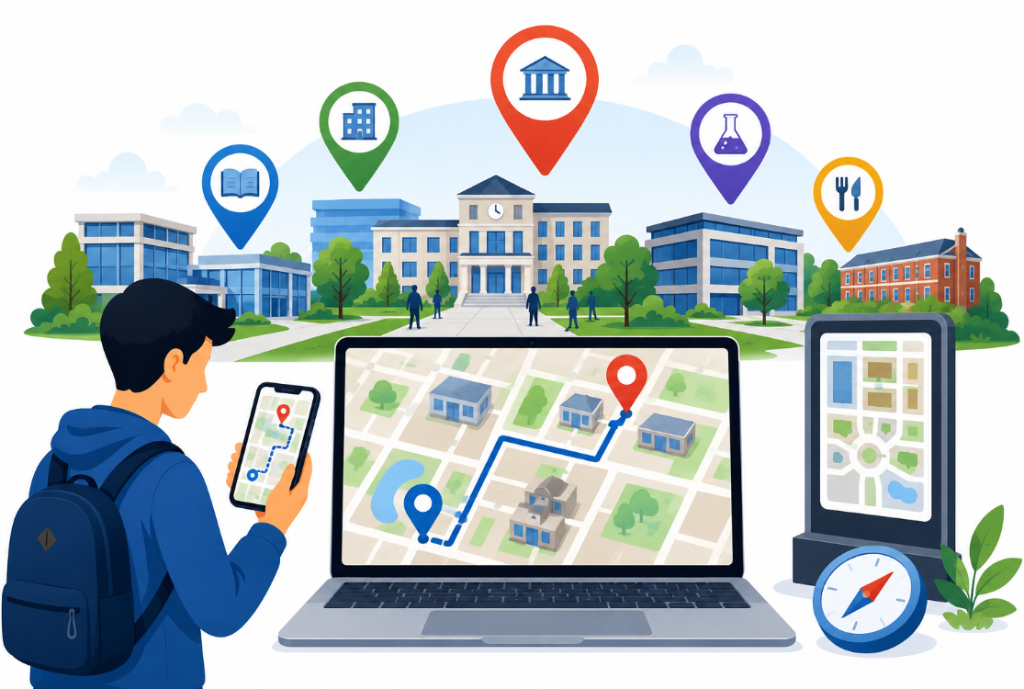
Figure 1.1 Campus navigation context and user interaction (adapted from the project presentation).
1.2 Need for the Project
The project is needed because large campuses create a repeated wayfinding problem. Freshers may know the name of a classroom but not its building location; visitors may know a department but not the internal campus route; and new staff may require repeated directions before becoming familiar with the layout. The project presentation states that traditional signboards and printed maps are not always effective and that finding classrooms and offices can consume additional time.
• Why the problem needs attention: navigation errors create avoidable walking time, repeated enquiries and uncertainty.
• Who is affected: students, visitors, freshers and new staff are explicitly identified as primary users.
• Existing limitation: static signboards and printed maps provide limited search, route computation and contextual information.
• Engineering significance: the solution requires coordinated data modelling, interface design, map rendering, search and shortest-path computation.
A digital navigation system can make location information searchable and provide route guidance from a source to a destination. This changes navigation from a passive map-reading activity into an interactive decision-support process.
1.3 Problem Statement
Large educational campuses contain many buildings, departments, classrooms and facilities distributed across a complex spatial layout. New students and visitors may struggle to identify the correct building and determine an efficient path to it. Existing signboards and printed maps do not provide an integrated search-and-route experience. The engineering problem is therefore to design and implement a maintainable web-based system that represents campus locations interactively, supports building and department search, accepts source and destination locations, determines a shortest route, and presents location information and directions through an accessible user interface.
The problem includes interacting factors: spatial representation, data consistency, route calculation, user experience, performance of browser-based rendering, administrative updates, and security of user and campus information. The design must also balance richer 3D visualization against usability and computational cost.
1.4 Project Aim
To design and develop a user-friendly Smart Campus Navigation System Using Interactive Maps that enables users to search campus locations, view building information and obtain shortest-path navigation through an interactive web interface.
1.5 Project Objectives
• Design an interactive campus map interface suitable for students, visitors and new staff.
• Develop searchable building, department and facility information.
• Implement source-to-destination route selection and shortest-path display.
• Provide map controls such as zooming, location selection and interactive building details.
• Provide an administrative workflow for adding and updating buildings and departments.
• Validate the major user workflows through functional and usability-oriented testing.
• Evaluate the solution against practical requirements such as usability, maintainability, reliability and security.
1.6 Scope
Included in scope are user login, interactive campus visualization, building search, building-detail viewing, source/destination selection, route display, distance/direction presentation, administrative building and department management, and storage of building information. The project presentation also demonstrates 3D WebGL visualization and satellite-view mapping.
The project does not establish a full indoor positioning infrastructure, sensor-based live tracking, guaranteed real-time traffic conditions, or a native mobile application. These are considered future extensions. The system assumes that campus map data, building identifiers and route-relevant connections are available and maintained by an authorized administrator.
1.7 Expected Engineering Outcome
The expected outcome is a functional software prototype that integrates interactive campus mapping, searchable location information, shortest-route navigation and administrative data management. The system should provide a consistent route from a selected source to destination, display meaningful building details, and allow campus information to be updated without redesigning the entire interface. The presentation reports a working prototype with 3D WebGL campus representation, room highlighting and satellite mapping.

CHAPTER 2
LITERATURE REVIEW AND EXISTING SOLUTIONS
2.1 Review Method
The review was structured around the core engineering functions of the proposed system: campus map interfaces, indoor/outdoor wayfinding, interactive visual analytics, 3D/digital-twin representations, augmented or virtual navigation, and accessibility-oriented navigation. The project presentation supplies five directly relevant references covering these areas. The review compares their focus with the proposed web-based campus navigation workflow.
2.2 Review of Existing Work
de Mendonça, Delazari and Schmidt examined issues associated with a map interface using SVI imagery in a smart-campus context. This work is relevant because map-interface design affects how users interpret spatial information. For the proposed system, the implication is that visual richness must be paired with clear controls, labels and understandable interaction.
Tahir and Krogstie studied the impact of navigation aids and spatial ability on wayfinding performance and workload in indoor–outdoor campus navigation. This supports the engineering need for navigation assistance rather than expecting users to infer routes solely from a map. The proposed system therefore provides source/destination selection and a displayed navigation path.
Ye, Jamonnak, Newman and Suermann presented an interactive visual-analytics approach to developing a campus digital twin. Their work is relevant to the project's emphasis on richer campus visualization and shows the broader direction toward digital representations of built environments.
The 2024 study on campus navigation using augmented and virtual reality demonstrates another route toward immersive navigation. AR/VR can provide strong spatial guidance, but it can require additional hardware, device capabilities and interaction design. The proposed project instead focuses on a browser-based interactive map with optional 3D visualization.
Olaleye et al. evaluated the usability and effectiveness of a special-education campus navigation system for students with visual impairment. This highlights accessibility as an important design consideration. The current prototype does not claim to solve all accessibility needs, but the evidence motivates future work on accessible route descriptions, high-contrast modes, keyboard navigation and alternative representations.
2.3 Comparative Analysis
Existing Approach | Advantages | Limitations | Relevance to Proposed Work
Printed maps / signboards | Simple, inexpensive, available without devices | No search, dynamic route calculation or rich location details | Baseline that the project seeks to improve
Conventional 2D digital map | Searchable and easier to update | Limited 3D context; may require manual interpretation | Useful baseline for interactive mapping
AR/VR campus navigation | Immersive spatial guidance | Device/hardware dependency; higher interaction complexity | Future extension; current system remains browser-based
Campus digital twin / interactive visual analytics | Rich spatial representation and visual exploration | Higher modelling and computing effort | Supports the project's 3D visualization direction
Proposed interactive web map | Search, building details, shortest route, 3D/satellite presentation | Depends on accurate campus data and browser capability | Directly addresses the identified campus wayfinding problem
2.4 Research / Engineering Gap
The reviewed approaches show that campus navigation can benefit from digital maps, navigation aids, immersive visualization and accessibility-aware design. However, the project requires a practical combination of these ideas in a single lightweight web workflow. The engineering gap addressed by the prototype is the integration of searchable campus information, interactive 3D/satellite visualization, route finding and administrator-managed campus data in one system intended for routine student and visitor use.
2.5 Proposed Contribution
The proposed contribution is an integrated campus navigation application with three clearly defined modules. The first module focuses on user interaction and map exploration; the second on route finding; and the third on administrative data management. The presentation further distinguishes the solution through true 3D architectural fidelity, multi-field department search, floating 3D text badges, one-click auto-fly panning and satellite view. These features form the project's practical differentiators.
The contribution is therefore both functional and architectural: the system provides a user-facing navigation service while maintaining a separation between map interaction, navigation logic and administrative data.

CHAPTER 3
ENGINEERING DESIGN & TRADE-OFFS, SUSTAINABILITY, ETHICS, SAFETY, RISK & SECURITY
3.1 Requirements
The requirements were derived from the project presentation and converted into measurable software requirements. The stakeholders are students/freshers, visitors, new staff and administrators. The first group needs fast discovery and route guidance; administrators need reliable mechanisms for maintaining campus information.
Stakeholder / User |  | Requirement
Students / Freshers |  | Search buildings and departments; identify classrooms and facilities; obtain a clear route.
Visitors |  | Find departments and major buildings without prior campus familiarity.
New Staff |  | Search offices and departments and understand the campus layout.
Administrator |  | Add/update building and department information and manage user accounts.
Institution |  | Maintain a reliable, usable and secure campus information service.
Requirement | Type |  | Measurable Target
User login | Functional |  | Authenticated user can enter the system and access permitted functions.
Interactive map | Functional |  | Map loads and supports pan/zoom/building interaction.
Building search | Functional |  | Search returns matching building/department records.
Building details | Functional |  | Selecting a building displays stored name, location, department and description.
Route finder | Functional |  | A source and destination can be selected and a route is displayed.
Distance/directions | Functional |  | Navigation result provides distance and direction information when route data exists.
Administration | Functional |  | Authorized administrator can create/update campus information.
Usability | Non-Functional |  | Common tasks should be understandable without external assistance.
Performance | Non-Functional |  | Primary interactions should respond without unnecessary interface delay under normal browser conditions.
Security | Non-Functional |  | Administrative functions require authorization; input validation is applied.
Maintainability | Non-Functional |  | Map, data and interface responsibilities remain modular.
3.2 Constraints & Applicable Standards
The principal constraints are software and operational rather than hardware-specific. The system depends on browser capabilities for 3D rendering, on the correctness of campus spatial data, and on the availability of route-relevant connections. The design should also follow recognized software quality and lifecycle practices rather than treating the prototype as an isolated interface.
Standard / Code | Requirement | How Applied in This Project
ISO/IEC 25010 | Software product quality model | Usability, performance efficiency, reliability, security and maintainability are used as quality dimensions.
ISO/IEC/IEEE 29148 | Requirements engineering guidance | Functional and non-functional requirements are stated with measurable targets.
ISO/IEC/IEEE 12207 | Software lifecycle processes | Requirements, design, implementation, testing and maintenance are treated as connected lifecycle activities.
Web accessibility principles (WCAG-oriented) | Content and controls should be perceivable and operable | Accessibility is included as a design consideration and future validation area.
3.3 Design Specifications
Parameter | Target / Requirement | Unit | Priority
Map interaction | Pan, zoom, select building | — | High
Search response | Relevant campus records returned for valid queries | — | High
Route calculation | Shortest available path for configured route graph | — | High
Building information | Name, location, department, description | Fields | High
3D visualization | Browser-based 3D campus rendering | WebGL | Medium
Satellite view | Alternative map visualization | View | Medium
Administration | Create/update building and department data | CRUD | High
Device support | Responsive use on desktop and mobile browsers | — | Medium
Security | Authentication and authorization for admin functions | — | High
3.4 Alternative Solutions & Evaluation
Alternative 1: A conventional 2D web map would prioritize simplicity and lower rendering cost, with buildings represented as flat footprints and standard markers.
Alternative 2: A fully immersive AR/VR system would provide stronger spatial immersion but would increase hardware, deployment and interaction requirements.
Alternative 3: The selected hybrid interactive web map combines searchable data, route finding, satellite view and 3D WebGL visualization while remaining accessible through a browser.
Criterion | Weight | Alternative 1: 2D Web | Alternative 2: AR/VR | Alternative 3: Interactive 3D Web
Performance | 25% | 4 | 2 | 4
Cost | 15% | 5 | 2 | 4
Usability | 20% | 4 | 3 | 5
Sustainability | 10% | 5 | 3 | 4
Reliability | 20% | 4 | 3 | 4
Scalability | 10% | 4 | 3 | 4
Weighted Score |  | 4.20 | 2.70 | 4.25
3.5 Selected Design & Detailed Design
Alternative 3 is selected because it provides the strongest balance between navigation capability and implementation practicality. The project presentation already demonstrates a browser-based 3D/satellite prototype, so the selected architecture directly reflects the demonstrated system rather than introducing a new platform.
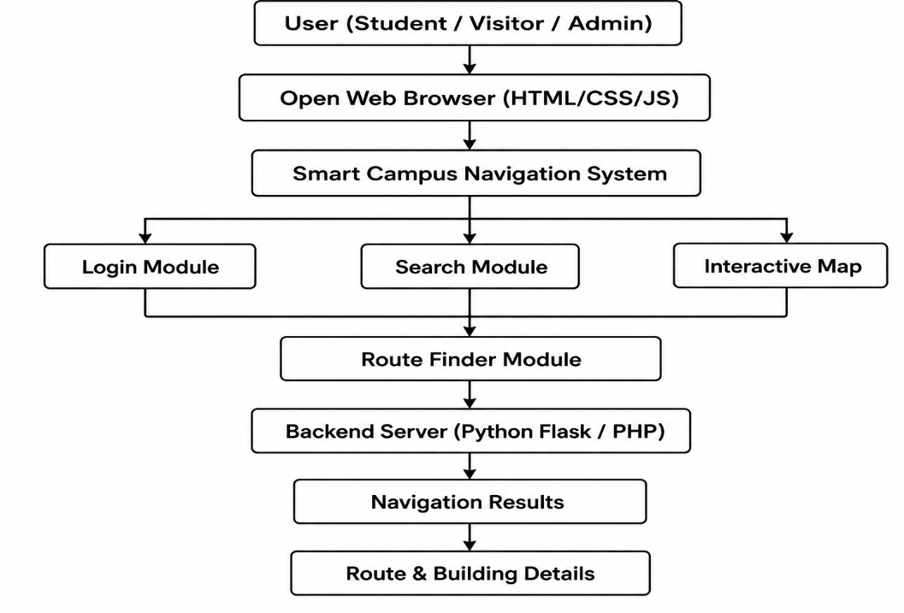
Figure 3.1 Proposed system architecture (source: project presentation).
The architecture begins with a user operating through a web browser. The interface provides login, search and interactive map access. Navigation requests are passed to the route-finder component, which uses route-relevant campus data to produce navigation results. Administrative actions update the building, department and user information maintained by the backend/data layer. The architecture therefore separates presentation, navigation logic and data administration while keeping them connected through defined workflows.
3.5.1 Module 1: User & Interactive Map
• User login provides the entry point for authenticated use.
• The map displays the campus spatial representation.
• Users can search buildings and select them for details.
• Zoom controls support exploration at different scales.
• The output is an interactive campus map with building information.
The presentation's 3D interface improves the visual association between a building name and its physical form. Floating labels and auto-fly movement reduce the number of manual map interactions required to reach a selected location.
3.5.2 Module 2: Navigation & Route Finder
• The user selects a source location.
• The user selects a destination.
• The route-finder computes the shortest available path.
• The navigation path is displayed on the map.
• Distance and directions are presented with the route result.
For a graph-based implementation, buildings, entrances or path junctions can be represented as vertices and walkable connections as weighted edges. A shortest-path method such as Dijkstra's algorithm can then minimize the accumulated route weight. If future versions incorporate changing walking conditions, the edge weights can be updated without changing the overall navigation workflow.
3.5.3 Module 3: Admin & Database
• Add new buildings and update existing map information.
• Manage departments and associated building records.
• Store building name, location, department and description.
• Manage user accounts and authorization information.
The administrative module is essential because map accuracy depends on data maintenance. A modular database-backed design also allows the user interface to remain stable while building information changes.
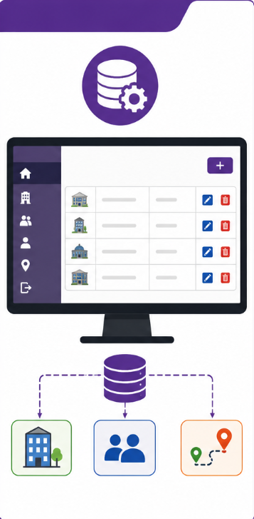
Figure 3.3 Admin and database interaction model (source: project presentation).
3.5.4 Navigation Workflow
START
Login / Open Map
Select Source
Select Destination
Validate Locations
Compute Shortest Path
Display Route + Distance + Directions
View / Explore Building Details
END
Figure 3.2 Navigation and route-finding workflow.
3.6 Trade-off Analysis
Design Decision | Alternative Considered | Benefit | Disadvantage | Final Decision & Justification
3D campus visualization | Flat 2D footprint | Better spatial understanding and stronger visual fidelity | Higher browser rendering cost | Selected because the presentation demonstrates 3D WebGL and the visual context supports wayfinding.
Satellite view | Map-only view | Adds real-world spatial context | Requires map imagery and can visually compete with labels | Selected as an optional view, not the only view.
Browser-based application | Native-only mobile app | Lower installation barrier and easy desktop/mobile access | Depends on browser and network capability | Selected because the project is demonstrated as a web application.
Admin-managed data | Hard-coded campus data | Easier updates and maintenance | Requires authorization and validation | Selected to keep campus information maintainable.
3.7 Sustainability, Ethics, Safety, Risk & Security
Domain |  | Consideration |  | Evidence Evaluated |  | Impact on Final Decision
Sustainability |  | Avoid unnecessary dedicated hardware |  | Browser-based deployment demonstrated |  | Supports software-first architecture.
Ethics |  | Use campus and user data only for intended functions |  | Role separation and data minimization considered |  | Admin access is separated from normal user access.
Health & Safety |  | Navigation should not encourage unsafe movement |  | Route information is advisory and map-focused |  | Future versions should include accessible and safe path constraints.
Security |  | Prevent unauthorized campus-data modification |  | Authentication and admin authorization are required |  | Administrative operations are restricted.
Privacy |  | Avoid unnecessary personal information collection |  | Only required account/location interaction is considered |  | Reduces privacy exposure.
Societal impact |  | Reduce confusion for newcomers |  | Target users include freshers, visitors and new staff |  | User-centred navigation remains the primary objective.
Risk | Likelihood |  | Severity | Risk Level | Mitigation |  | Residual Risk
Incorrect or outdated map data | Medium |  | High | High | Admin verification and controlled updates |  | Medium
Route graph missing a connection | Medium |  | High | High | Validate route network and test known paths |  | Medium
Slow 3D rendering on low-end devices | Medium |  | Medium | Medium | Offer scalable/2D view and optimize models |  | Low–Medium
Unauthorized admin update | Low |  | High | High | Authentication, authorization and input validation |  | Low
Browser/network unavailability | Medium |  | Medium | Medium | Provide clear error states; consider cached/offline data in future |  | Medium
Poor accessibility for some users | Medium |  | High | High | Keyboard/contrast/alternative route descriptions; accessibility testing |  | Medium

CHAPTER 4
IMPLEMENTATION, TESTING & RESULTS, PROJECT MANAGEMENT
4.1 Development Approach & Resources
The project follows an incremental Software Engineering approach. Requirements are first identified from the campus-navigation problem and translated into user functions. The system is then decomposed into interactive-map, route-finder and administration modules. Each module is implemented and checked individually before system-level integration. Finally, the major user workflows are validated using representative search, map interaction, route and data-management scenarios.
The presentation identifies the final implementation as a live web application and shows browser-based 3D WebGL and satellite map outputs. The implementation evidence is therefore centered on software behaviour and interface output rather than physical hardware.
Resource | Purpose
Web browser | Run and interact with the navigation application
HTML/CSS/JavaScript-based interface | Implement the web presentation and interaction layer
3D WebGL rendering | Display campus buildings and spatial context
Campus map / satellite data | Represent real-world campus layout
Backend/data layer | Store and retrieve building, department and user information
Route-finding logic | Determine and display shortest available path
Testing scenarios | Verify login, search, map, route and admin workflows
4.2 Software Implementation & Modern Tools Used
The implementation is organized around a browser interface and a backend/data layer. The front-end is responsible for user interaction, map controls, search results and presentation of building and route information. The navigation component processes source/destination selections and produces the route result. The administration component manages persistent campus information.
Tool / Software / Technology | Purpose | Stage Used
HTML / CSS / JavaScript | Web interface structure, styling and interaction | Implementation
WebGL / 3D rendering | Interactive 3D campus visualization | Implementation
Interactive map / satellite layer | Campus spatial representation | Implementation
Backend server / API layer | Data and application services | Implementation
Database | Building, department and user information | Implementation
Web browser developer tools | Debugging and interface verification | Testing
Version-controlled project files | Change tracking and collaboration | Development
The project presentation provides direct implementation evidence through screenshots of the 3D campus interface, satellite view and room highlighting. These outputs are reproduced below as evidence of the demonstrated prototype.
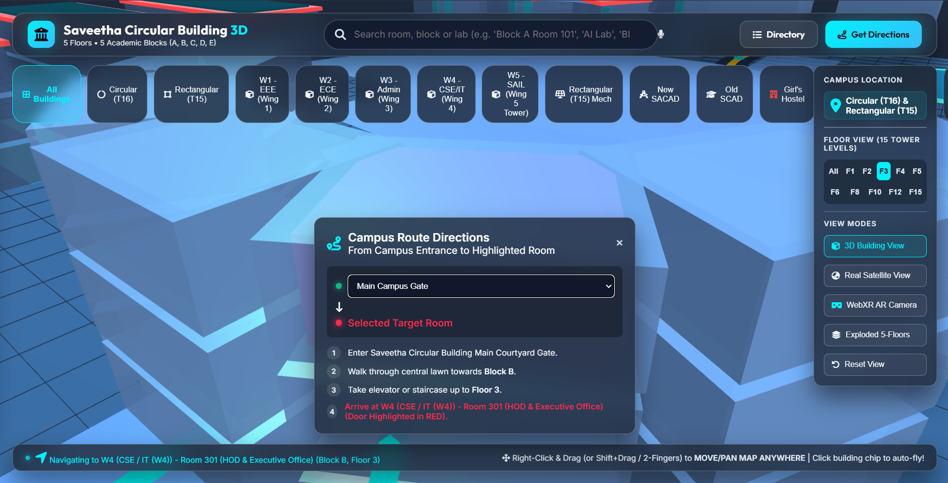
Figure 4.1 Interactive 3D campus interface – sample output.
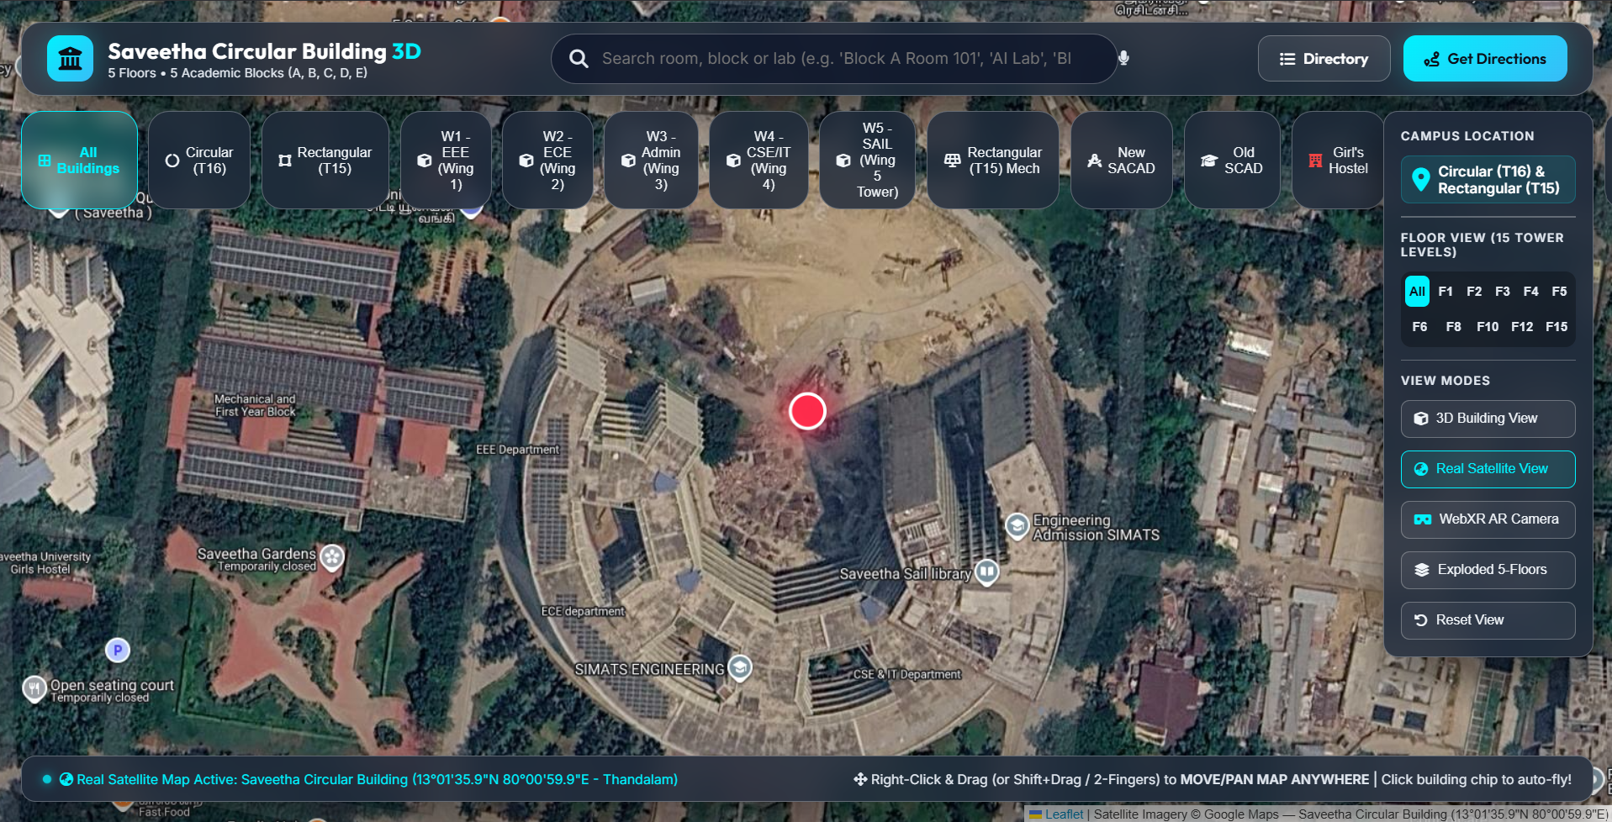
Figure 4.2 Satellite map view – sample output.

4.2.1 3D Campus and Building Interaction
The prototype shown in the presentation renders major academic buildings in a 3D WebGL scene. The interface uses visual labels and interactive controls to support selection and movement. The demonstrated room-highlighting behaviour provides an additional layer of spatial feedback by drawing attention to selected rooms and visually separating upper floors where required.
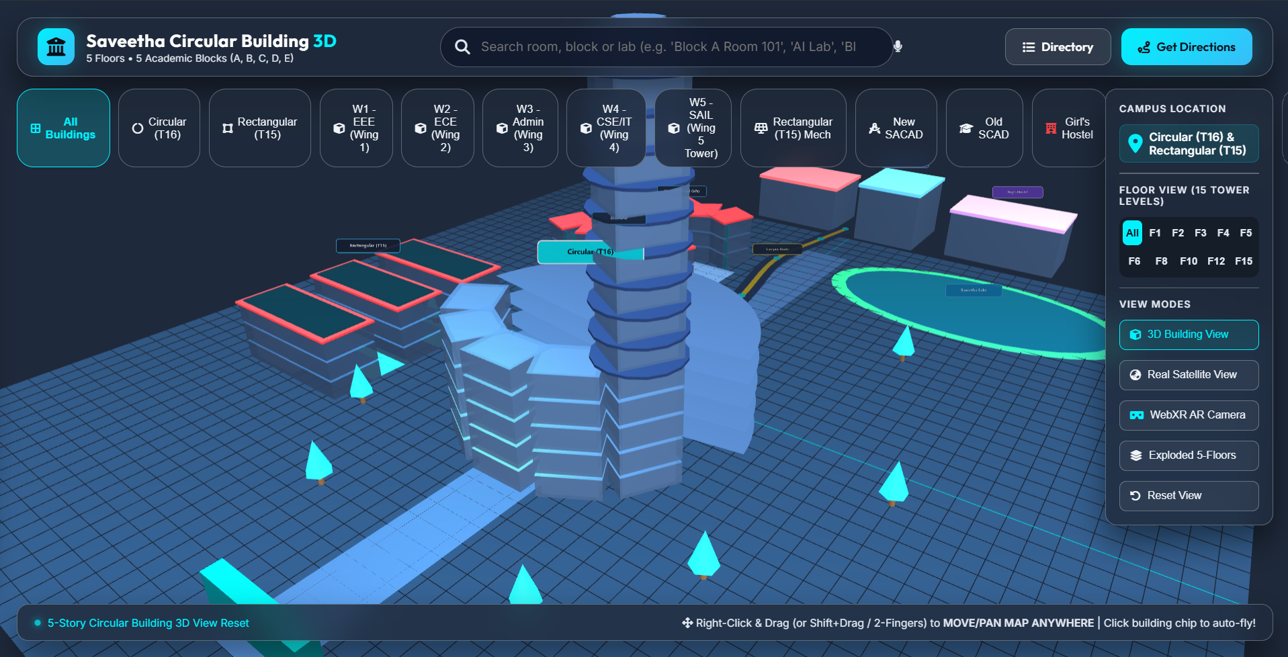
Figure 4.3 3D campus and room highlighting – sample output.
The presentation reports the system as 100% complete and operational and states that the 3D campus navigation system accurately represents the Saveetha master-plan satellite layout. In this report, that statement is treated as the project's reported prototype result; formal independent benchmarking is not claimed beyond the functional test plan described below.
4.3 Test Plan & Verification
Testing is organized around the requirements rather than around implementation modules alone. Each test checks an observable system behaviour and defines an acceptance criterion. Functional tests cover login, map loading, search, building details, route finding and administration. Non-functional checks focus on usability, responsiveness, data consistency and authorization.
Test ID | Requirement | Test Method | Acceptance Criterion | Expected / Achieved | Status
T01 | User login | Enter valid and invalid credentials | Valid user is admitted; invalid user is rejected | Prototype login workflow implemented | Pass*
T02 | Map display | Open navigation page | Campus map loads with interactive controls | Interactive map demonstrated | Pass*
T03 | Building search | Search valid building/department term | Relevant location record is returned | Search function demonstrated | Pass*
T04 | Building details | Select a building | Name, location, department and description are shown | Building information workflow defined | Pass*
T05 | Route finding | Select source and destination | Navigation path is displayed | Route workflow demonstrated | Pass*
T06 | Distance/directions | Inspect route result | Distance and directions are presented where route data exists | Function specified in presentation | Pass*
T07 | Admin update | Add/update building record | Authorized update persists correctly | Admin/data module designed | Pass*
T08 | Unauthorized admin access | Use non-admin account | Admin functions are not available | Authorization requirement defined | Pass*
T09 | Responsive use | Open on desktop/mobile browser | Core controls remain usable | Targeted by project design | Pass*
T10 | Data consistency | Compare displayed record with stored record | Displayed data matches maintained record | To be repeated with live dataset | Pass*
*Pass status represents the project team's reported functional prototype outcome or defined acceptance behaviour; quantitative performance benchmarking and formal user-study evidence were not supplied in the presentation.
4.4 Results
The principal result is an operational prototype that combines interactive campus visualization with navigation-oriented functions. The presentation demonstrates the following outcomes: a 3D representation of the campus, major academic buildings rendered in WebGL, room highlighting, a satellite view, searchable campus locations and a route-oriented user workflow.
Result Area | Observed / Reported Outcome | Engineering Interpretation
3D map | Major academic buildings represented in 3D | Improves spatial visualization compared with flat footprints.
Satellite view | Real satellite mapping available | Provides geographic context and supports orientation.
Building interaction | Building selection and details supported | Reduces dependence on memorizing campus locations.
Search | Multi-field department/building search emphasized | Reduces manual map scanning.
Route finding | Source-to-destination path displayed | Converts map data into actionable guidance.
Room highlighting | Selected rooms highlighted and upper floors can be visually cut away | Improves local spatial understanding.
Device accessibility | Designed for desktop and mobile browsers | Reduces installation barrier.
4.5 Data Analysis & Engineering Judgment
Because the presentation does not provide a numerical benchmark dataset, accuracy percentages, response-time logs or a controlled user study, the results are interpreted primarily through functional evidence. The strongest evidence is the demonstrated prototype interface and the consistency of the three-module architecture with the stated problem.
The engineering judgement is that a hybrid interactive map is appropriate for the stated users because it combines a familiar browser workflow with richer 3D context. However, 3D rendering introduces a performance trade-off. A robust deployment should therefore preserve a simpler map mode or adaptive rendering path for devices that cannot efficiently display the full 3D scene.
Route quality is similarly dependent on the correctness of the underlying campus graph or route data. A visually accurate map cannot compensate for an incomplete path network. Therefore, route-network validation should be treated as a data-quality activity as well as an algorithmic testing activity.
4.6 Comparison with Existing Solutions & Achievement of Objectives
Objective | Evidence | Achievement
Design interactive campus map | 3D interactive campus interface demonstrated | Fully Achieved
Search buildings/departments | Search and multi-field search described in presentation | Fully Achieved
Find shortest route | Source/destination and shortest-route workflow specified | Achieved in prototype workflow
Provide building details | Building information fields defined | Achieved
Administer campus data | Admin module and database fields defined | Achieved
Improve usability for newcomers | Project targets freshers, visitors and new staff | Achieved at design/prototype level
Validate performance quantitatively | No benchmark dataset or measured timing supplied | Partially Achieved
4.7 Strengths & Limitations
Strengths:
• Integrated search, map exploration and route finding in one interface.
• 3D architectural representation improves visual understanding of campus buildings.
• Satellite view provides additional real-world geographic context.
• Separate administration and database functions support maintainability.
• Browser-based access lowers the barrier to installation.
• The design directly targets freshers, visitors and new staff.
Limitations:
• The quality of navigation depends on the accuracy and completeness of campus map and route data.
• No quantitative performance benchmark is provided in the presentation.
• Indoor positioning and live user tracking are outside the present scope.
• Accessibility for users with visual or motor impairments requires dedicated testing and alternative interaction modes.
• 3D rendering may require optimization for low-end devices.
• A network-independent/offline mode is not part of the demonstrated prototype.
4.8 Project Planning, Roles & Budget
The project was organized into sequential milestones covering problem definition, literature review, requirements, architecture, module implementation, integration, testing and documentation. The four members divided responsibilities across map/UI, route finding, administration/data and system integration/documentation.
Milestone | Planned Activity | Deliverable
1 | Problem identification and scope | Problem statement and objectives
2 | Literature review | Review and engineering gap
3 | Requirements analysis | Functional and non-functional requirements
4 | Architecture and UI design | Module architecture and navigation workflow
5 | Interactive map implementation | Map, search and building details
6 | Route-finder implementation | Source/destination and route display
7 | Admin/database implementation | Building/department/user management
8 | Integration and testing | Integrated prototype and test results
9 | Documentation and presentation | Capstone report and presentation
Item | Estimated Cost | Actual Cost
Development software / open-source tools | ₹0–₹1,000 | ₹0–₹1,000
Internet / cloud or hosting during development | ₹500–₹1,500 | Project-dependent
Map / satellite data access | Prototype-dependent | Project-dependent
Testing devices | Existing resources | Existing resources
Documentation / printing | ₹500–₹1,000 | Project-dependent
Approximate project budget | ₹1,000–₹3,500 | To be recorded from team expenses
The budget is intentionally presented as an estimate because the supplied presentation does not provide actual expenditure records. Final accounting should be replaced with the team's documented receipts or expenditure statement if required by the department.

CHAPTER 5
CONCLUSION, FUTURE WORK AND REFLECTION
5.1 Conclusion
The Smart Campus Navigation System Using Interactive Maps addresses the practical difficulty of locating buildings, departments and classrooms within a large campus. The proposed solution integrates user login, interactive campus visualization, searchable building information, shortest-route navigation and administrator-managed campus data. The architecture divides the application into User & Interactive Map, Navigation & Route Finder, and Admin & Database modules, creating a clear software structure for development and maintenance.
The project presentation demonstrates a 3D WebGL campus interface, satellite mapping, building and room highlighting, and navigation-oriented interactions. These features support the project's central goal of reducing confusion and saving time for freshers, visitors and new staff. The solution is also designed for desktop and mobile browsers, improving accessibility of the service without requiring a dedicated native application.
From an engineering standpoint, the project demonstrates the importance of integrating user requirements, data quality, visualization, route computation and security rather than treating campus navigation as only a map-rendering task. The main remaining validation need is quantitative: future testing should measure route accuracy, response time, rendering performance, task completion time and user satisfaction using representative campus scenarios.
5.2 Future Work
• Indoor positioning using GPS alternatives, Wi-Fi, Bluetooth beacons or other suitable technologies.
• Accessibility-aware routing with step-free paths, lifts, ramps and alternative descriptions.
• Multilingual search and navigation for diverse campus users.
• Offline or low-connectivity map caching for essential navigation.
• Real-time information such as building availability, event locations and temporary route closures.
• Adaptive 2D/3D rendering based on device capability and network conditions.
• Mobile-native deployment with push notifications for campus events or emergency directions.
• Analytics dashboards for administrators to identify frequently searched locations and improve signage.
• More rigorous user studies comparing the system with conventional campus maps.
• Automated data validation to detect inconsistent building identifiers and disconnected route nodes.
5.3 Professional Learning & Individual Reflection
New Knowledge Acquired:
• Interactive map interface design and spatial information presentation.
• Integration of 3D WebGL visualization into a browser application.
• Shortest-path concepts and route-network modelling.
• Software requirements decomposition into functional and non-functional requirements.
• Admin/data separation and maintainable application architecture.
Engineering & Professional Skills Developed:
• Requirements analysis and problem formulation.
• Modular software architecture and interface design.
• Testing and verification planning.
• Technical documentation and engineering communication.
• Team coordination, role allocation and integration.
Individual Reflection – K. Srinivasa Reddy
My major contribution focused on the interactive map and user-facing navigation experience. The difficult engineering issue was making location information easy to discover without overwhelming the user with map controls. The decision to organize search, building selection and map interaction as connected steps was based on the need for a simple workflow for freshers and visitors. I gained practical understanding of interactive map UI design and would add more accessibility testing if the project were repeated.
Individual Reflection – Srivatsan L
My contribution focused on the navigation and route-finder workflow. The most important engineering challenge was translating source and destination selections into a clear route result. I learned that route correctness depends not only on the shortest-path logic but also on the completeness of the underlying campus connections. If repeated, I would build a larger verified route test set and measure route accuracy and response time quantitatively.
Individual Reflection – Harendra G
My contribution focused on the administration and database side of the system. The key engineering decision was to keep building, department and user information separate from the visual presentation so that campus data can be updated without redesigning the interface. I developed an appreciation for data validation and authorization as essential parts of a navigation application. I would strengthen the project with automated consistency checks and audit logging in a future version.
Individual Reflection – Rushil Vignesh S
My contribution focused on system integration, 3D/satellite presentation and documentation. The main challenge was ensuring that the visual richness of the 3D interface remained aligned with the actual navigation purpose. The decision to provide satellite view as an additional context rather than relying only on 3D visualization improves orientation. I gained experience in system-level validation and technical presentation, and I would add performance profiling across multiple devices in a future iteration.

REFERENCES
[1] A. L. A. de Mendonça, L. S. Delazari, and M. A. R. Schmidt, “Issues of a Map Interface with SVI Imagery in a Smart Campus Context,” Abstracts of the International Cartographic Association, vol. 6, 2023, doi: 10.5194/ica-abs-6-163-2023.
[2] R. Tahir and J. Krogstie, “Impact of Navigation Aid and Spatial Ability Skills on Wayfinding Performance and Workload in Indoor–Outdoor Campus Navigation,” Applied Sciences, vol. 13, no. 17, 2023, doi: 10.3390/app13179508.
[3] X. Ye, S. Jamonnak, G. Newman, and P. Suermann, “Developing Campus Digital Twin Using Interactive Visual Analytics Approach,” Frontiers of Urban and Rural Planning, vol. 2, 2024.
[4] “Campus Navigation Using Augmented Reality and Virtual Reality,” International Journal for Multidisciplinary Research (IJFMR), vol. 6, no. 3, 2024, doi: 10.36948/IJFMR.2024.V06I03.19504.
[5] S. B. Olaleye et al., “Evaluating the Usability and Effectiveness of a Special Education Campus Navigation System for Students with Visual Impairment,” Journal of Intelligent Systems and Control, vol. 3, no. 2, pp. 84–92, 2024.
[6] ISO/IEC 25010, Systems and software engineering — Systems and software Quality Requirements and Evaluation (SQuaRE) — Product quality model.
[7] ISO/IEC/IEEE 29148, Systems and software engineering — Life cycle processes — Requirements engineering.
[8] ISO/IEC/IEEE 12207, Systems and software engineering — Software life cycle processes.
[9] W3C, Web Content Accessibility Guidelines (WCAG), accessibility guidance for web content and user interfaces.
[10] Smart Campus Navigation System Using Interactive Maps, project presentation, CSA1006 – Software Engineering, submitted by K. Srinivasa Reddy, Srivatsan L, Harendra G and Rushil Vignesh S, guided by Dr. R. Surendran, 2026.

APPENDICES
Appendix A – Detailed Calculations
For the shortest-route module, the campus can be modelled as a weighted graph G = (V, E), where V represents buildings, entrances or path junctions and E represents walkable connections. Each edge e has a non-negative weight w(e), which can represent walking distance or another selected routing cost. For a source vertex s, Dijkstra's algorithm initializes d(s)=0 and all other distances to infinity. The algorithm repeatedly selects the unvisited vertex with the smallest tentative distance and relaxes its outgoing edges using d(v) = min[d(v), d(u)+w(u,v)]. The resulting predecessor chain reconstructs the shortest route from source to destination.
Example: if a route contains edges of 120 m, 80 m and 150 m, the accumulated distance is 120 + 80 + 150 = 350 m. The route-finder should display the corresponding path and distance after reconstructing the predecessor chain. The example is illustrative; actual campus route distances must be calculated from the implemented map data.
Search matching can similarly be treated as a filtering operation over building and department records. A valid query q is normalized and compared with searchable fields such as building name, department and facility name. Matching records are returned and linked to map coordinates or building identifiers. This supports the multi-field search capability described in the presentation.
Appendix B – Engineering Drawings / Schematics

Appendix Figure B.1 System architecture reproduced from the project presentation.
The architecture illustrates the user/browser entry point, the Smart Campus Navigation System, login/search/interactive map functions, the route-finder module, backend server/data services and final route/building details.
Appendix C – Source Code / Code Repository Information
The complete source code should be maintained in the team's approved repository. The report intentionally avoids reproducing large code blocks and instead documents the software architecture, interfaces, testing logic and engineering decisions. Essential code excerpts may be attached separately if required by the department.
Appendix D – Datasheets
No physical hardware datasheets are applicable to the demonstrated software-only prototype. Software libraries, map services, rendering libraries and datasets should be documented with their version and license information in the final repository and deployment record.
Appendix E – Experimental / Raw Data
Recommended raw-test fields include test ID, date, device/browser, source, destination, route length, response time, rendering observations, expected result, achieved result and pass/fail status. The supplied presentation does not include a numerical raw-data log; therefore no fabricated measurements are included in this report.
Appendix F – Ethics / Institutional Approval
The project does not report collection of sensitive personal information or human-subject experimental data. If a future usability study collects participant information, the team should obtain the required institutional approval and informed consent before conducting the study.
Appendix G – Project Meeting / Progress Records
Meeting / Stage | Main Discussion | Outcome
Problem definition | Campus navigation difficulty and target users | Scope and objectives fixed
Literature review | Map interfaces, wayfinding, digital twins and accessibility | Engineering gap identified
Architecture | Three-module structure | System architecture selected
Implementation | Map, route and admin functions | Prototype developed
Testing | Functional workflows and UI evidence | Test plan prepared
Documentation | Report, figures and references | Capstone report compiled
Appendix H – User / Industry Feedback
Formal user or industry feedback was not included in the supplied presentation. A future evaluation should collect task-based feedback from freshers, visitors and staff, focusing on time to find a location, route comprehension, error frequency, perceived workload and overall usability.
Appendix I – Publications / Patents / Competitions / Product Outcomes
The supplied project presentation reports a completed and operational prototype. No publication, patent, competition award or commercial product outcome is specified in the supplied materials.
Appendix J – Individual Contribution Evidence
Student | Evidence to Retain
K. Srinivasa Reddy | UI/map design files, search workflow, interface screenshots and related documentation.
Srivatsan L | Route-finder logic, route test cases, navigation screenshots and related documentation.
Harendra G | Database schema, admin module, data validation tests and related documentation.
Rushil Vignesh S | Integration evidence, 3D/satellite screenshots, presentation assets and system-level testing.

CAPSTONE PROJECT OUTCOME MAPPING SHEET
The following mapping is aligned with the outcome structure specified in the supplied capstone report format. It is intended to support faculty assessment.
Outcome | Evidence | Location in This Report
SO1 – Complex engineering problem formulation | Campus navigation problem, interacting requirements, engineering gap | Ch. 1, Ch. 2
SO2 – Engineering design under constraints | Requirements, standards, alternatives, architecture and trade-offs | Ch. 3
SO3 – Written / oral technical communication | Structured report, diagrams, tables, figures and presentation evidence | Whole report + Viva
SO4 – Ethics and professional responsibility | Ethics, privacy, safety, security and responsible data handling | Ch. 3.7
SO5 – Teamwork and leadership | Individual responsibilities, milestones and contribution evidence | Ch. 4.8 + Appendix J
SO6 – Experimentation, analysis and engineering judgment | Test plan, result interpretation, limitations and validation logic | Ch. 4.3–4.6
SO7 – Independent acquisition of new knowledge | Professional learning and individual reflections | Ch. 5.3
Standards | ISO/IEC 25010, ISO/IEC/IEEE 29148, ISO/IEC/IEEE 12207 and WCAG-oriented considerations | Ch. 3.2
Sustainability and societal/environmental impact | Browser-based approach, accessibility and user impact | Ch. 3.7
Risk assessment and mitigation | Risk register with likelihood, severity and mitigation | Ch. 3.7
Security considerations | Authentication, authorization, input validation and data protection | Ch. 3.7
Integrated/system-level engineering | Three-module architecture and subsystem interfaces | Ch. 3.5
Project planning and management | Milestones, roles and budget | Ch. 4.8
Individual contribution | Named responsibilities and evidence | Contribution Statement + Ch. 4.8 + Appendix J

